Linux assignment module 5
- Advance topics in a function
Write a function add to add two numbers and call the function in another file
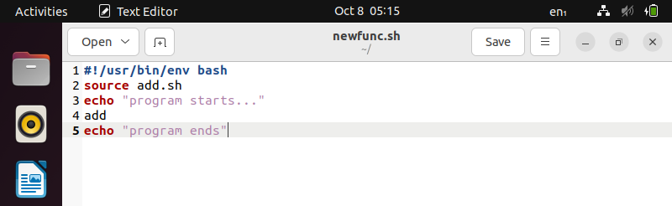
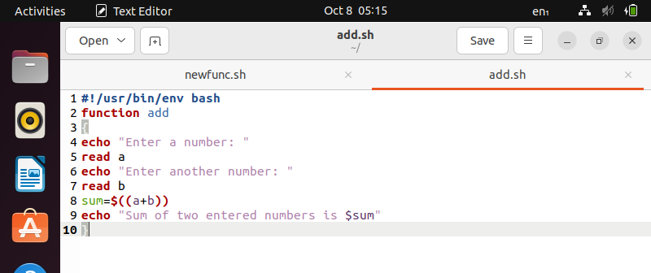
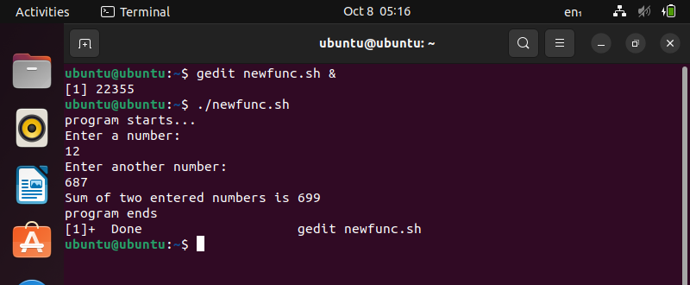

- Recursive function
Write a program where the recursive function calculates the sum of N numbers
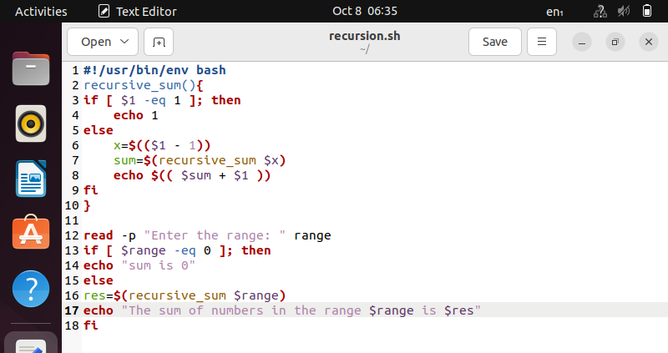
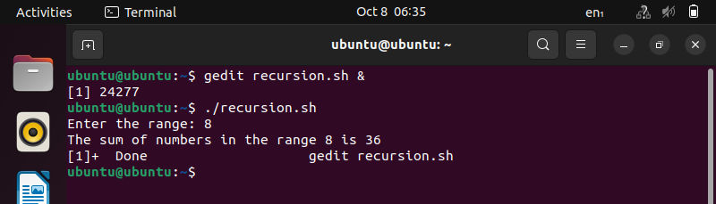

- Basics of redirection (error handling)
Create a text file with some content like your name, address. Redirect the content to a new file.
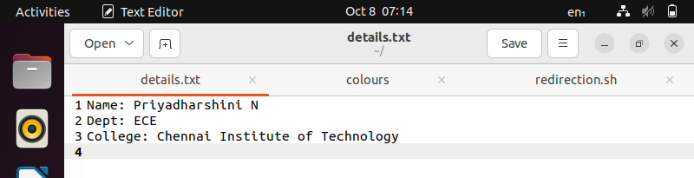
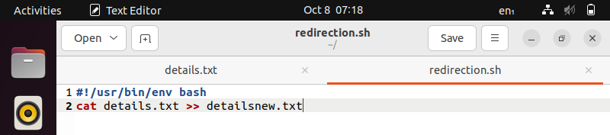
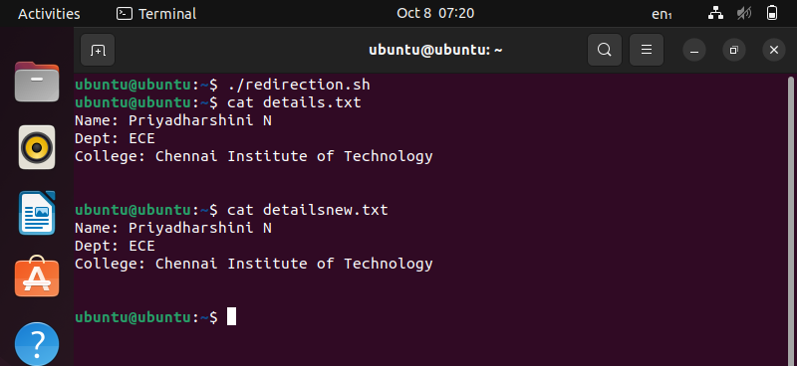

- More on redirection
- Create X_file.txt file with some content. 2) Redirect the content of both out_file.txt and X_file.txt to a new file
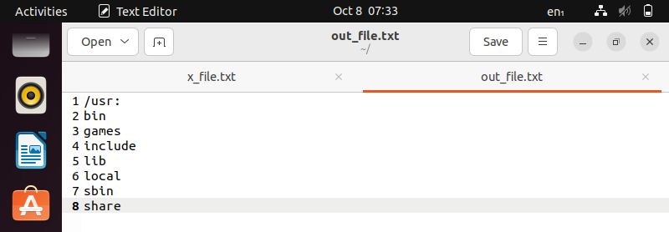
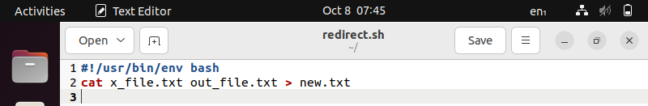

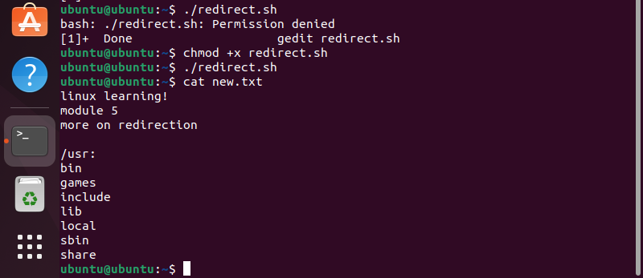

- Here document and here string
1) Convert a string to uppercase using: a) Here document b) Here string Hint: tr a-z A-Z
